# NEPTUNE ACADEMY PRIMARY, JUNIOR AND SENIOR SCHOOLS P.O BOX 11722 — 00100, UMOJA, NAIROBI

# STUDENT REPORT CARD

NAME  **FATUMA ABDI** ADM NO.  **127** FORM  **FORM 1** TERM  **TERM 2** EXAM **ENDTERM** YEAR  **2024 _**

MEAN GRADE  **B-** POSITION **1** OUT OF **4 _**

|  |  |  |  |  |  |  |  |
| --- | --- | --- | --- | --- | --- | --- | --- |
| CODE | SUBJECTS | Opener | Midterm | Endterm | Dev | REMARKS | TEACHER |
| 100 | ENGLISH | 52 B- | 25 D | 12 E | -26 | Good | Ondari |
| 101 | KISWAHILI | 36 C- | 52 B- | 55 B | +11 | Good | Polly |
| 202 | MATHEMATICS | 60 B+ | 5 E | 96 A | +63 | Very Good | Partrick |
| 123 | BIOLOGY | 22 D | 96 A | 48 C+ | -11 | Good | Charles |
| 342 | PHYSICS | 55 B | 55 B | 55 B | 0 | Excellent | Wycliffe |
| 333 | CHEMISTRY | 86 A | 96 A | 80 A | -11 | Good | Wycliffe |
| 331 | HISTORY | 35 C- | 44 C | 12 E | -27 | Good | Sandra |
| 165 | GEOGRAPHY | 66 A- | 52 B- | 55 B | -4 | Good | Miriam |
| 112 | CRE | 88 A | 85 A | 36 C- | -50 | Poor | Doris |
| 213 | AGRICULTURE | 14 E | 88 A | 88 A | +37 | Good | Charles |
| 445 | COMPUTER | 76 A | 96 A | 69 A- | -17 | Good | Erick |
| 559 | BUSINESS | 36 C- | 14 E | 30 D+ | +5 | Exellent | Jackline |
|  | |  |  |  |  |  |  |
| MEAN | | 52 | 59 | 53 | -2 |  |  |
| GRADE | | B- | B | B- |  |  |  |
|  | |  |  |  |  |  |  |

# GRAPHICAL PROGRESS

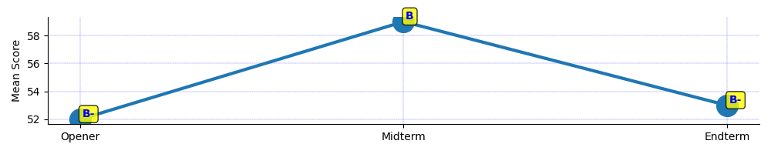

**CLASS TEACHER'S COMMENTS: Your progress is amazing. I have no doubt that next time you will soar as high as an eagle. Keep up the good work and never give up. _**Date: .................................................. Signature: ..................................................

School has closed today on  **Monday 01 August, 2024 _** and reopens next time on  **Wednesday 27 August, 2024 _**

Parent / Guardian's Signature: ................................................................................

FORM 1 & 2 (MARKS): **E:** 0–14; **D-:** 15–19; **D:** 20–29; **D+:** 30–34; **C-:** 35–39; **C:** 40–44; **C+:** 45–49; **B-:** 50–54; **B:** 55–59; **B+:** 60–64; **A-:** 65–69; **A:** 70–100; FORM 3 & 4 (POINTS): **E:** 7–10; **D-:** 11–17; **D:** 18–24; **D+:** 25–31; **C-:** 32–38; **C:** 39–45; **C+:** 46–52; **B-:** 53–59; **B:** 60–66; **B+:** 67–73; **A-:** 74–80; **A:** 81–84;

# NEPTUNE ACADEMY PRIMARY, JUNIOR AND SENIOR SCHOOLS P.O BOX 11722 — 00100, UMOJA, NAIROBI

# STUDENT REPORT CARD

NAME  **FATUMA ABDI** ADM NO.  **130** FORM  **FORM 1** TERM  **TERM 2** EXAM **ENDTERM** YEAR  **2024 _**

MEAN GRADE  **C+** POSITION **2** OUT OF **4 _**

|  |  |  |  |  |  |  |  |
| --- | --- | --- | --- | --- | --- | --- | --- |
| CODE | SUBJECTS | Opener | Midterm | Endterm | Dev | REMARKS | TEACHER |
| 100 | ENGLISH | 33 D+ | 25 D | 11 E | -18 | Good | Ondari |
| 101 | KISWAHILI | 29 D | 11 E | 85 A | +65 | Good | Polly |
| 202 | MATHEMATICS | 77 A | 9 E | 14 E | -29 | Very Good | Partrick |
| 123 | BIOLOGY | 22 D | 25 D | 36 C- | +12 | Good | Charles |
| 342 | PHYSICS | 69 A- | 96 A | 66 A- | -16 | Excellent | Wycliffe |
| 333 | CHEMISTRY | 58 B | 77 A | 45 C+ | -22 | Good | Wycliffe |
| 331 | HISTORY | 47 C+ | 25 D | 36 C- | 0 | Good | Sandra |
| 165 | GEOGRAPHY | 88 A | 69 A- | 77 A | -1 | Good | Miriam |
| 112 | CRE | 89 A | 47 C+ | 36 C- | -32 | Poor | Doris |
| 213 | AGRICULTURE | 77 A | 85 A | 65 A- | -16 | Good | Charles |
| 445 | COMPUTER | 80 A | 90 A | 77 A | -8 | Good | Erick |
| 559 | BUSINESS | 63 B+ | 58 B | 12 E | -48 | Exellent | Jackline |
|  | |  |  |  |  |  |  |
| MEAN | | 61 | 51 | 46 | -10 |  |  |
| GRADE | | B+ | B- | C+ |  |  |  |
|  | |  |  |  |  |  |  |

# GRAPHICAL PROGRESS

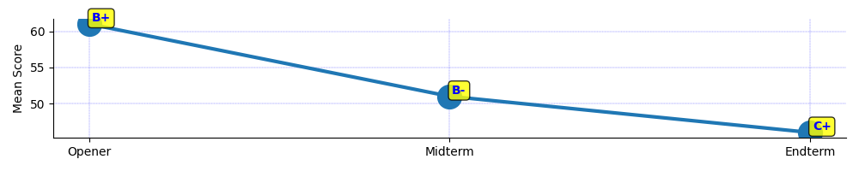

**CLASS TEACHER'S COMMENTS: Your progress is amazing. I have no doubt that next time you will soar as high as an eagle. Keep up the good work and never give up. _**Date: .................................................. Signature: ..................................................

School has closed today on  **Monday 01 August, 2024 _** and reopens next time on  **Wednesday 27 August, 2024 _**

Parent / Guardian's Signature: ................................................................................

FORM 1 & 2 (MARKS): **E:** 0–14; **D-:** 15–19; **D:** 20–29; **D+:** 30–34; **C-:** 35–39; **C:** 40–44; **C+:** 45–49; **B-:** 50–54; **B:** 55–59; **B+:** 60–64; **A-:** 65–69; **A:** 70–100; FORM 3 & 4 (POINTS): **E:** 7–10; **D-:** 11–17; **D:** 18–24; **D+:** 25–31; **C-:** 32–38; **C:** 39–45; **C+:** 46–52; **B-:** 53–59; **B:** 60–66; **B+:** 67–73; **A-:** 74–80; **A:** 81–84;

# NEPTUNE ACADEMY PRIMARY, JUNIOR AND SENIOR SCHOOLS P.O BOX 11722 — 00100, UMOJA, NAIROBI

# STUDENT REPORT CARD

NAME  **FATUMA ABDI** ADM NO.  **225** FORM  **FORM 1** TERM  **TERM 2** EXAM **ENDTERM** YEAR  **2024 _**

MEAN GRADE  **B** POSITION **3** OUT OF **4 _**

|  |  |  |  |  |  |  |  |
| --- | --- | --- | --- | --- | --- | --- | --- |
| CODE | SUBJECTS | Opener | Midterm | Endterm | Dev | REMARKS | TEACHER |
| 100 | ENGLISH | 12 E | 22 D | 15 D- | -2 | Good | Ondari |
| 101 | KISWAHILI | 36 C- | 85 A | 88 A | +27 | Good | Polly |
| 202 | MATHEMATICS | 25 D | 22 D | 63 B+ | +39 | Very Good | Partrick |
| 123 | BIOLOGY | 14 E | 74 A | 85 A | +41 | Good | Charles |
| 342 | PHYSICS | 52 B- | 22 D | 44 C | +7 | Excellent | Wycliffe |
| 333 | CHEMISTRY | 47 C+ | 36 C- | 78 A | +36 | Good | Wycliffe |
| 331 | HISTORY | 22 D | 84 A | 42 C | -11 | Good | Sandra |
| 165 | GEOGRAPHY | 58 B | 36 C- | 36 C- | -11 | Good | Miriam |
| 112 | CRE | 32 D+ | 96 A | 85 A | +21 | Poor | Doris |
| 213 | AGRICULTURE | 55 B | 47 C+ | 44 C | -7 | Good | Charles |
| 445 | COMPUTER | 41 C | 85 A | 36 C- | -27 | Good | Erick |
| 559 | BUSINESS | 42 C | 72 A | 59 B | +2 | Exellent | Jackline |
|  | |  |  |  |  |  |  |
| MEAN | | 36 | 56 | 56 | +10 |  |  |
| GRADE | | C- | B | B |  |  |  |
|  | |  |  |  |  |  |  |

# GRAPHICAL PROGRESS

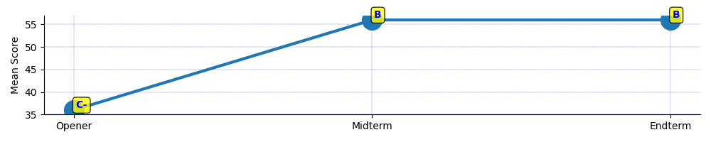

**CLASS TEACHER'S COMMENTS: Your progress is amazing. I have no doubt that next time you will soar as high as an eagle. Keep up the good work and never give up. _**Date: .................................................. Signature: ..................................................

School has closed today on  **Monday 01 August, 2024 _** and reopens next time on  **Wednesday 27 August, 2024 _**

Parent / Guardian's Signature: ................................................................................

FORM 1 & 2 (MARKS): **E:** 0–14; **D-:** 15–19; **D:** 20–29; **D+:** 30–34; **C-:** 35–39; **C:** 40–44; **C+:** 45–49; **B-:** 50–54; **B:** 55–59; **B+:** 60–64; **A-:** 65–69; **A:** 70–100; FORM 3 & 4 (POINTS): **E:** 7–10; **D-:** 11–17; **D:** 18–24; **D+:** 25–31; **C-:** 32–38; **C:** 39–45; **C+:** 46–52; **B-:** 53–59; **B:** 60–66; **B+:** 67–73; **A-:** 74–80; **A:** 81–84;

# NEPTUNE ACADEMY PRIMARY, JUNIOR AND SENIOR SCHOOLS P.O BOX 11722 — 00100, UMOJA, NAIROBI

# STUDENT REPORT CARD

NAME  **FATUMA ABDI** ADM NO.  **290** FORM  **FORM 1** TERM  **TERM 2** EXAM **ENDTERM** YEAR  **2024 _**

MEAN GRADE  **B-** POSITION **4** OUT OF **4 _**

|  |  |  |  |  |  |  |  |
| --- | --- | --- | --- | --- | --- | --- | --- |
| CODE | SUBJECTS | Opener | Midterm | Endterm | Dev | REMARKS | TEACHER |
| 100 | ENGLISH |  |  | 25 D | - | Good | Ondari |
| 101 | KISWAHILI |  |  | 36 C- | - | Good | Polly |
| 202 | MATHEMATICS |  |  | 11 E | - | Very Good | Partrick |
| 123 | BIOLOGY |  |  | 85 A | - | Good | Charles |
| 342 | PHYSICS |  |  |  | - | Excellent | Wycliffe |
| 333 | CHEMISTRY |  |  | 80 A | - | Good | Wycliffe |
| 331 | HISTORY |  |  | 36 C- | - | Good | Sandra |
| 165 | GEOGRAPHY |  |  |  | - | Good | Miriam |
| 112 | CRE |  |  | 85 A | - | Poor | Doris |
| 213 | AGRICULTURE |  |  |  | - | Good | Charles |
| 445 | COMPUTER |  |  | 70 A | - | Good | Erick |
| 559 | BUSINESS |  |  |  | - | Exellent | Jackline |
|  | |  |  |  |  |  |  |
| MEAN | |  |  | 53 | - |  |  |
| GRADE | |  |  | B- |  |  |  |
|  | |  |  |  |  |  |  |

# GRAPHICAL PROGRESS

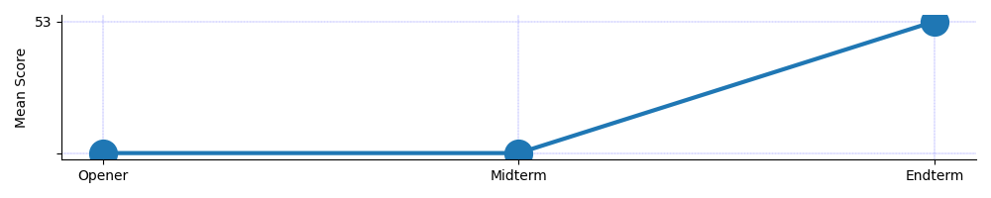

**CLASS TEACHER'S COMMENTS: Your progress is amazing. I have no doubt that next time you will soar as high as an eagle. Keep up the good work and never give up. _**Date: .................................................. Signature: ..................................................

School has closed today on  **Monday 01 August, 2024 _** and reopens next time on  **Wednesday 27 August, 2024 _**

Parent / Guardian's Signature: ................................................................................

FORM 1 & 2 (MARKS): **E:** 0–14; **D-:** 15–19; **D:** 20–29; **D+:** 30–34; **C-:** 35–39; **C:** 40–44; **C+:** 45–49; **B-:** 50–54; **B:** 55–59; **B+:** 60–64; **A-:** 65–69; **A:** 70–100; FORM 3 & 4 (POINTS): **E:** 7–10; **D-:** 11–17; **D:** 18–24; **D+:** 25–31; **C-:** 32–38; **C:** 39–45; **C+:** 46–52; **B-:** 53–59; **B:** 60–66; **B+:** 67–73; **A-:** 74–80; **A:** 81–84;